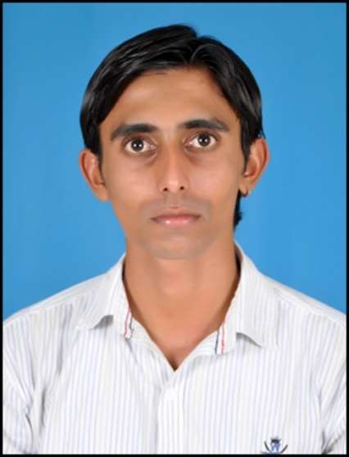RESUME

STATEMENT OF PURPOSE:

SPECIALIZATION:

Bachelor in Computer Application
(BCA)

CONTACT INFORMATION:

Name: Dadga Tanvi Bhumitkumar .

Mobile: +91-7041490835

E-Mail :
tanvipatel804@gmail.com

CONTACT ADDRESS:

To.: Pitruchhaya palace, Ukani nagar,
Bidada-mandvi.
Mandvi–Kutch-370 435 PERSONAL DETAILS:
Date of birth :25/05/1994 Sex : Female
Height :156cm
Weight : 49 kg Nationality :Indian Marital status:Married
Cast :Hindu

LANGUAGES KNOWN:

- English
- Hindi
- Gujarati

HOBBIES:

Reading NewsPaper, Net Surfing, Listening music, Play indoor Game etc.
I would like to put my best effort in learning practical aspects of computer and information Technology. My aim would be to make a mark in the company with the help of my hard efforts and toil put in together with patience and passion to do work.

AREAS OF INTREST:
- Computing
- Internet Access
- Ms Office
- Access C, Java, HTML, CSS, etc.
- Computer based Activities.

PROFESSIONAL STRENGTHS:
- In any type of condition I do my best and try to held work without ttension.
- Good team management, communication skills and leadership qualities.
- Solving the problem that’s on my way.
- Adaptable to new work places and environment very easily.
- Proactive, self-motivated and Honest.
- Keenly interested in learning new technologies to become technological Sound.

ACADEMIC RECORD:

Semester | Institute/ school | Board / University | Year of passing | Percentage
BCA | MJSB College-Bhuj-kutch | Kutch University | 2014 | CGPI-7.39
H.S.C. | Punjani  High-School Gadhsisa | G.H.S.E.B | Mar-2011 | 76.00%
S.S.C. | Punjani  High-School Gadhsisa | G.S.E.B. | Mar-2009 | 75.50%

College/Institute : MJSB Mahila College, Bhuj-Kutchh University : Kutchh university, Bhuj.

WORK EXPERIENCE:

- Experienced in Shree Saraswati Vidhya-Mandir, Gadhsisa as a Computer & English teacher in class six to Ten for 4 years .
- Do work in Gadhsisa High-School as English and Computer Teacher in Higher Secondary Section for year.
TECHNICAL SKILL:

- Proficient in Basic programming in Computer.
- Knowledge about Basic c, c++, Java, Php .
- Do work with HTML and CSS.
- Be updated with new versions.
- Understand OOP concept .
- Technological Development.
- Strong Knowledge of searching, sorting, graphics.
- Basic Understanding of web security.
SKILL SETS:

- Quick Learner
- Good Communication Skills
- Good at time Management
- Good Team Player
- Ability to meet deadlines

PROJECT WORK:
- LIC Management
- Work Affiliation:
Company name : LIC Branch, Bhuj
Location : MJSB College, Bhuj (India)
Duration : From1st March 2014 To 20th March 2014
Position : Trainee

EXTRA CURRICULAR ACTIVITIES:
.
- Attended Webinar “Generative AI Mastermind” on Outskill under the Guidence of Sir Vaibhav Sisinty.

DECLARATION:

I confirm that the information provided by me is true and correct to the best of my knowledge and belief. I assure you that if I am given a chance to serve in your organization than I will work honestly, sincerely and enthusiastically towards the achievement of yours organizational goals and objectives.

Date: / / Dadga Tanvi B.

